Riverwalk Quilters Guild Newsletter
Naperville, Illinois
Volume 33 Issue 1
July 11, 2023

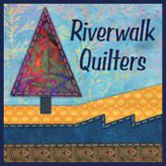 |  | 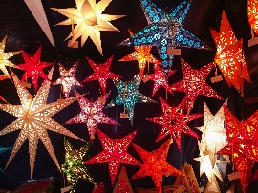  Happy Fiscal RQG New Year
Please make sure you read all the news…every page has information you can use!

This month:

Page 1
- Cover Page
Page 2
- President’s Message:
- A thank you from our outgoing President & Vice President
- Congratulations to our winner

Page 3
Guest Speakers
- On July 11th Kitty Wilkin -“Quilt Photography”
- On August 8th Laura Hartrich – “Labels as a Love Language”
- Library News

Page 4
- Membership & Directory Reports
- Philanthropy Report

Page 5
- Rummage Sale Report
- Video Communication Report
Page 6
- Programs
- Workshops

Page 7
- Small Quilt Auction Report
- Newsletter Ads
Page 8
- Executive Board & Committee Positions
Page 9
- RQG Membership Information Form
President’s Message |  | A Hearty Party Thank You
We ended June with a great anniversary party—thanks Leesa, Linda, and Amy—and now we’re starting an exciting year.  Welcome to our very capable new board, already busily at work (check the end of this newsletter for their names).  Nancy Sturgeon has arranged a full schedule of speakers and is planning the annual small quilt auction in October as one of our programs.  See her report below for more information about the auction and how you can help. There’s something for everyone to do!  I’m honored to be the new guild president, taking over from Loraine, who did a superb job, as did the whole outgoing board. Big shoes to fill!  If you and I haven’t officially met, I hope you’ll introduce yourself.  If you have suggestions or comments, please feel free to share them.  I’m looking forward to this year and hope you are too.  Bev Parker  President |  | It’s hard to beat the dynamic party planning trio of Leesa Jump, Linda McShea, and Amy Shuter.  Many thanks to these ladies who planned a fun celebration last month, the 29th anniversary of our guild.  The beautiful tables, clever favors, snacks, and games all made for a delightful evening.  We hope you had a chance to connect with other guild members.  With a robust attendance of 60, it was evident that even without a speaker, we like being together!  Many thanks to Julie Milldrum for chairing the rummage sale and handling nearly all the leftovers.  Did you find some treasures? Maybe we’ll soon see some of those unique fabrics in a future show n’ tell.  Thanks to all who contributed items for the local food pantry.  And congratulations to our charter members who have participated in and supported our guild since 1994!  Loraine Nemo & Bev Parker
Passing the Gavel |  | CONGRAtULATIONS
It has been a complete pleasure to serve the guild these past two years. As president, I just oversee and coordinate.  The board members do the lion’s share of the work, so many thanks to the board! You have made my job easy and enjoyable.  Thanks also to Mary Cieslak who preceded me as president. Mary provided detailed, organized files and the inspiration to get me started.  I am excited about the coming year and am glad to pass the gavel (actually a bell) to the very capable and perspicacious Bev Parker.  She will be an excellent leader. Please support her this year.  With kindest regards,  Loraine Nemo |  | We had a great turnout for our guild’s 29th anniversary party.  Bernina of Naperville donated this Bernette sewing machine, won by our new member Robin Bennett.  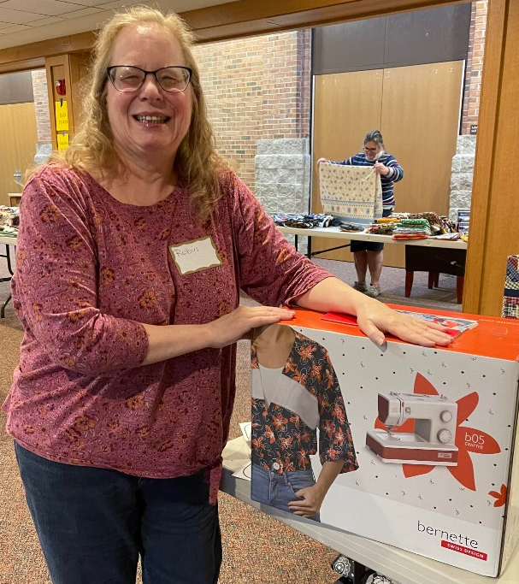  Congrats Robin and thanks very much to Bernina of Naperville.  www.berninaofnaperville.com  Bev Parker

Guest Speaker July 11, 2023  Take Great Quilt Photos Now |  | GUEST SPEAKER Coming August 8, 2023  “Labels as a Love Language”
KITTY WILKIN  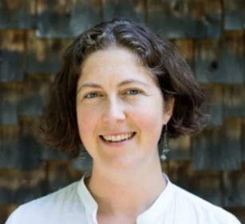  Guild Zoom LECTURE (Can be viewed either at Knox Church or at your home.)  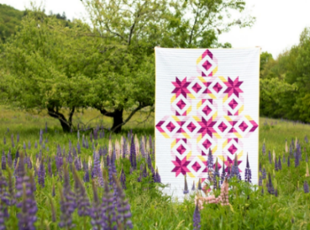  Learn pro quilt photography tips that can take your photos from meh to wow. Kitty is known for her outdoor photography. A self-taught quilt photographer, she uses the outdoors and natural lighting as the backdrop for her quilt photos.  She’s known for choosing unusual locations and perspectives to shoot her quilts “in the wild.” She will also discuss photographing quilts indoors.  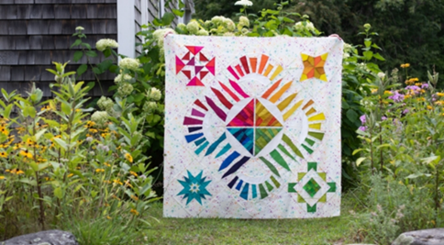  For more about Kitty:  Google "Kitty Wilkin Quilt Photography".https://nightquilter.com  Instagram: @nightquilter Pinterest: Kitty Wilkin  Facebook: nightquilter YouTube: Kitty Wilkin – Night Quilter  Twitter: @nightquilter TikTok: @nightquilter  Flickr: night.quilter |  | Laura Hartrich of Oak Park, Illinois, is an artist working mostly in quilts. Some of these are heartfelt gifts made especially for a beloved recipient.  Some are art works with themes of reflection, acceptance, time, and memory.  She's currently going back to school after a 15-year hiatus and is loving her undergraduate art classes.  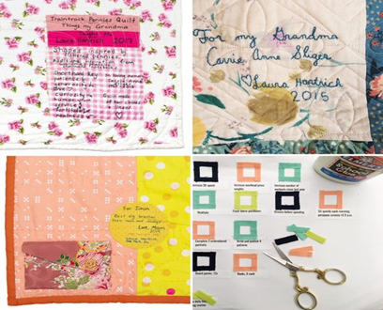  GUILD LECTURE—  In Person Knox Church & also on Zoom  In this presentation Laura will talk about how labels factor into her quilt-making practice.  She will share many images as she discusses technique, inspiration, and motivation for creating labels as detailed and unique as her quilts themselves.  Every quilt needs a label!  http://www.laurahartrich.com/  instagram @laurahartrich

LIBRARY NEWS
We are Sandy Doubek and Judy Morgan, and we have taken on the task of Librarians for the 2023 - 2024 year.

We will have a selection of books at the meeting on July 11th, so come see us.

MEMBERSHIP |  |  | PHOTO DIRECTORY
Membership Renewals:  Thank you to all the members who have already renewed for the 2023-2024 year.  For those who have not renewed, please dust off the checkbook and bring the $35.00 dues (Riverwalk Quilters Guild) and the form with your information to our July 11 meeting. You can also bring cash.  You will find the form at the end of this newsletter. The form  is fillable on your computer or can be handwritten.  We have a great list of speakers and activities this year.  Guest fee is $10 per meeting. It will be subtracted from the membership fee if they want to join.  A new member folder is available with all the information and badge directions about our guild. |  |  | Photo Directory:  We still need a few more pictures. Please come and see me at the meeting for the photo shoot. We will send out the photo directory soon.  Remember to wear your badge at the meeting to win a door prize!!!  Margaret Zitt  Membership and Photo Directory
NEW PHILANTHROPY CHAIRS |  |  | FORMER PHILANTHROPY CHAIRS
Hello all,  Lisa K and I (Sandy H) just wanted to introduce ourselves as the new philanthropy board members. Lisa is very experienced and continues to learn more about quilting every day at work at her quilt shop.  I was an ER nurse for many years, and now I love everything there is about quilting. I am a beginner but I am watching U-tube videos all about quilting which actually are very helpful.  Lisa and I plan to work very hard to make sure we carry on the wonderful work done by the previous philanthropy team.  Terry and Judy did such a fine job it will be hard to follow in their footsteps but we sure will give it our all.  Please consider helping to make our years a success by picking up quilts to finish at the philanthropy table.  We are looking forward to meeting all of you and having a great two years!!!  Lisa K and Sandy H |  |  | Judy and I would like to thank the guild board and guild members for their support during our four-year term with philanthropy. We have enjoyed our time getting to know our fellow guild members and meeting people in various organizations that serve our community. We also welcome Sandy and Lisa to the philanthropy committee.  At our June party/rummage sale we received 2 quilts quilted, 1 bound quilt, and 1 top completed and quilted. Thank you, Nancy S. ,Sandy H. and Darlene S.  I may have left someone out. If I did, I apologize, my excuse, shopping and enjoying the party. I hope everyone else had fun and found some treasures.  We were very busy delivering quilts, pillowcases, and hand warmers. A total of 45 quilts, 8 pillowcases and 2 hand warmers went to the following organizations: Our Savior Lutheran Church, Habitat for Humanity, Joliet Children's Advocacy Center, Monarch Springs, Northwestern Medical Center, and Ronald McDonald House.  The following totals of donations are from July 2022 to June 2023.  Quilts 260, Pillowcases 163, Hand warmers 53, Burp bibs 141, receiving blankets 22, Christmas stockings 250, and 3 reading pillows. It's been a wonderful year of giving.  Sincerely,  Terri Hayes and Judy Long

rummage sale |  | Rummage Sale Second Chance
What fun we all had at the rummage sale. Finding that special piece of fabric, magazine, or treasure that make our hearts zing. Or even finding the fabric that you gave last year. We are so lucky to have this special community that gives and shares in such a passionate manner.  Our treasures went to our friends, our community (Discoveries resale Store-Outreach community services), Out of State (Wahpeton Sioux Reservation, Sisseton South Dakota) and Africa (South Sudan Voices of Hope). The 4-H on the Wahpeton Sioux reservation is so delighted to have the 4-H fabric that they wanted to especially thank whoever donated it.  A big loud shout out to all my wonderful volunteers from the people who took and sorted the donations into the various places, the checkout people and the diligent people who cleaned up afterwards. We could not have done it without all the team effort. Many hands make quick work.  The sale made . $1,224.85  Next year’s sale is June 11, 2024.  So, when I say to Dane, my husband, that.  Oh, I just have to have this.  This will match something in my stash.  This will make my point so much better……but didn’t.  I don’t care, I’m going to buy it anyway.  I know how I can use it.  We have plenty of money……Ha! Ha!  I deserve it?????  Just give me your wallet. Yes, I do, do that.  I don’t care.  Then you get home and say after two years why did you buy that, Julie? Bring it to the rummage sale next year.  But please don’t ask me or any of the committee members to store them. They have enough of their own excuses.  Do not miss the July after rummage sale. The leftover magazines and treasures that we overlooked in June will be out for purchase at the July sale.  So, I hope you find a bargain that you might not have seen in June.  Julie Mildrum |  | Thanks to generous stash donations, our June rummage sale was a big success with a profit of $1,224.85.  Many thanks to Julie Milldrum our rummage chairperson, who organized the sale and will be funneling many of the leftovers to charitable organizations.  A few choice leftovers will return to our July meeting for a Second Chance sale, so bring some cash or your checkbook.  There just may be something there that calls out to go home with you.
 |  | VIDEO COMMUNICATIONS
Hi everyone,

Two things:

We are in need of a person to help with the video communication position.

The job requires knowledge of zoom and organization skills to coordinate other helpers. I am willing to train you on zoom.

For show and tell we need a laptop or tablet with a rear camera that can be signed into the zoom meeting and project to the zoom audience. If you can help with that, please contact me ASAP.

As always, if you would like to be moderator during the year at one or more of our meetings, I will train you for that also. Join in the fun this year!

Please contact me at RQGVideoCom@gmail.com to discuss.

Thank you for all that you do!
Kathleen Herbach

PROGRAMS 2023-2024 |  | WORKSHOP—Taught by Nancy Sturgeon
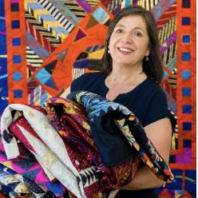  September 12—Julia McLeod is an international award-winning quilt maker living and working near San Francisco.  Born and raised in England, she worked as a textile designer in the woolen and worsted mills of Yorkshire and Scotland before taking a job with a luxury tailoring company on London’s Savile Row.  A design position at a menswear company in New York City brought her to the US. Julia discovered quilt making on travels through the small Amish towns of Pennsylvania.  Since 2016 she has specialized in making silk quilts, sourcing her fabrics from neckties, clothing and furnishing fabrics.  She has a passion for reuse and recycling, which leads her to rescue vintage blocks and textiles. These reclaimed fabrics become the starting point for her quilt designs. https://juliamcleodquilts.com.  Everything but the Cotton—Let’s explore the world of quilts that were made with what I call ‘Not Cottons’. When quilters don’t have access to a stash of quilter’s cotton, what do they turn to?  This one-hour lecture, trunk show and Q &amp; A session shows quilts – antique and modern – made of wool, silk, polyester and more.  The trunk show of Julia’s work shows what you can create with neckties, saris, kimonos, and other unusual, ‘not cotton’ textiles. |  | Saturday, September 16 th  Silk Tie Wall Hanging (6 blocks or more).  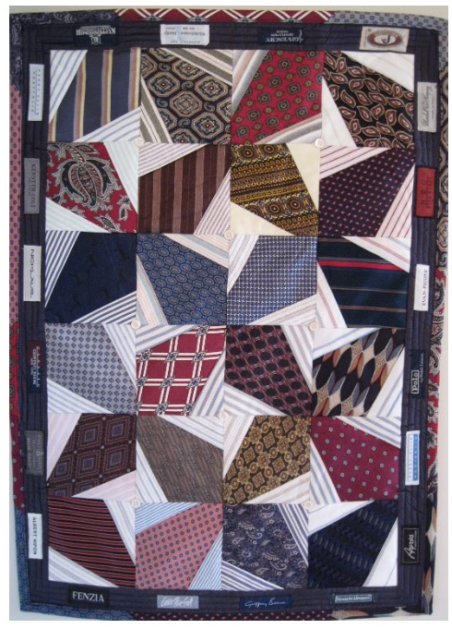  Location to be determined. If you know of a place that we can use for the above Saturday morning, please let me know. We will split the rent between those of us in the class.  Cost is minimal--No teaching fee—morning class?  You will learn simple foundation paper piecing in order to construct the blocks for a small wall hanging made from men’s silk or polyester neckties.  The pattern is from a book (Ties for Guys by Cyndy Rymer) that is now out of print; however, I can purchase online print-on-demand copies for each student for about $4.15 each plus tax. I will teach the class.  I have a zillion ties here that I am in the process of deconstructing so I think you will be able to choose enough ties for the project from my stash or you can bring your own.  They will need to be washed and pressed before class. You will also need some men’s cotton shirts.  Save the buttons. More details to follow on supplies.  I will have a sign-up sheet and tie prep instructions at the  July 11th meeting along with the larger quilt I made and several wall hangings.

SMALL QUILT AUCTION 10/17/23 |  | NEWSLETTER ADS
The Riverwalk Small Quilt Auction is held every year at 7 p.m. on the third Tuesday in October using a professional auctioneer at Grace United Methodist Church  300 E. Gartner Rd., Naperville, IL.  When we don’t schedule a quilt show for the following year, this auction is our most important money-making event.  We need the funds to cover our expenses for room rental for our meetings, speaker fees which just keep climbing, supplies for philanthropy like batting, etc.  All RQG members are asked to donate an item or two that they have made. We don’t accept bed-sized quilts but prefer smaller more decorative items. Wall hangings are good.  You can donate a table runner, placemats, baby quilts, smaller quilts, etc.  Fall, Halloween, and winter holiday items usually go for a decent price.  Prior to the event, members hang the items in the room for viewing.  During the auction, each piece is paraded around the room so guests and members may once again look up closely.  Last year in addition to the auction, we included a boutique for smaller items. There is only so much time in an evening, and though the thought of many items sounds nice, there isn’t time for 80 or 90 items to go in the auction.  Smaller items are sold in the boutique. We encourage RQG  members to start making items now for the auction and boutique and to invite their friends when the time comes.  This is a very festive night, and everyone has a fun time.  Start planning your auction donations now Time flies.  Any questions, please email me.  Nancy Sturgeon, Auction Chair/Programs Chair |  | The Riverwalk Quilters Guild newsletter is published monthly.  To submit articles for inclusion, contact our RQG Newsletter Chair by the 4th Tuesday of the month.  Guild members may place free ads for personal use only.  Please make sure the ad is directly related to our shared hobby.  If the ad is for a business, Rates are as follows:  Full Page: $50.00  Half Page: $25.00  Quarter Page: $12.50  Eighth Page: $5.00  Full page ad available for a single month only.  Make checks out to Riverwalk Quilters Guild and mail to the following address:  Riverwalk Quilters Guild  PO Box 5092  Naperville, IL 60567

2023 – 2024 RQG EXECUTIVE BOARD & COMMITTEE POSITIONS
POSITION | 2023 - 2024  NEW EXECUTIVE BOARD CHAIRS
President  RQGPresident@gmail.com | Bev Parker
Vice President  RQGVicePresident@gmail.com | Mara Gallager
Secretary  RQGSecretary@gmail.com | Mary Saba
Treasurer  RQGTreasurer@gmail.com | Ganga Gubbi

POSITION | 2023 - 2024  NEW COMMITTEE CHAIRS
Contracts  RQGContracts@gmail.com | Nancy Sturgeon
Holiday Party  RQGHoliday@gmail.com | Deb Obrecht & Peggie Getz
Library  RQGLibrarian@gmail.com | Sandy Doubeck & Judy Morgan
Membership  RQGMembership@gmail.com | Margaret Zitt
Newsletter  RQGNewsletter@gmail.com | Mary Cieslak
Philanthropy  RQGPhilanthropy@gmail.com | Lisa Klingbeil & Sandra Heraty  & Fabric Fondler’s Bee
Photo Membership Directory | Margaret Zitt
Programs  RQGPrograms@gmail.com | Sherry Gendel
Rummage Sale | Julie Milldrum
Small Quilt Auction | Nancy Sturgeon
Social Media  RQGSocialMedia@gmail.com | Margaret Donahue
Special Events | Sherry Gendel
Video Communications  RQGVideoCom@gmail.com | Position Open
Website  RQGWebsite@gmail.com | Rosemary Sanza
a/o 6/30/23

Riverwalk Quilters Guild Member Information Form
July 1, 2023 - June 30, 2024
Please print clearly |  |  | Check here if there are no changes in your information from last year.
Name
Street
City, State, Zip
Phone
Email

How did you hear about Riverwalk Quilters Guild?

If you belong to a quilting bee, which one?

Would you be interested in joining a Bee? | Yes: | No:

If yes, what time of the week are you available to meet with a bee? | Day: | Evening: | Weekend:

What are your areas of interest about quilting for finding programs and workshops for our meetings? Check all that apply.
 | Traditional quilt design |  | Handwork (EPP, Applique, Embroidery, Sashiko)
 | Modern quilt design |  | Machine quilting on domestic machines (walking foot, free motion, etc.)
 | Art quilts |  | Hand quilting
 | Quilt history |  | Long arm quilting
 | Other

Indicate your interests or abilities that could be helpful to our guild by checking any of the items below. Check all that apply.
 | Meeting/committee leadership |  | Artistic ability / crafting skills
 | Secretarial skills |  | Graphic arts/design
 | Bookkeeping/accounting |  | Computer skills / Zoom
 | Marketing / Publicity |  | Event planning (i.e., Quilt shows, quilt auctions, annual party)
 | Other

Do not use photos of me or publish my work in the newsletter, on the website, or on social media.

I understand that I am obliged to volunteer for guild activities.
Signature

Membership and Guest Rates (Please check the box below that applies)
 | Renewal / New member fee: | $35/year
 | Fee for newsletter and membership directory sent by U.S. Mail | $12/year
 | Pro-rated membership fee - new member after January 1st: | $20
 | Guest Fee: | $10/meeting

Make check payable to Riverwalk Quilters Guild and mail it along with this form to:
Riverwalk Quilters Guild Membership  P.O. Box 5092  Naperville, IL 60567 |  | Office Use Only
 |  | Date
 |  | Amount Paid
 |  | Check number
 |  | Cash
Revised 7/5/23

